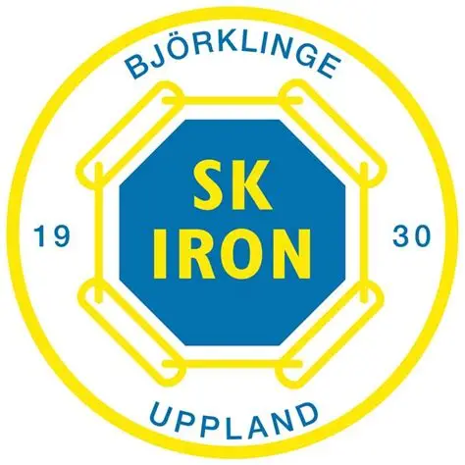

***Inventeringsformulär inför säsongen 2025/2026***

Lag

___________________________________________________________________________

Ansvarig tränare/ Kontaktuppgifter

_____________________________________________________________________________

Datum

_____________________________________________________________________________

**Västar**

|  |  |  |  |  |
| --- | --- | --- | --- | --- |
| Storlek | Röd | Orange | Grön | Blå |
| Mini |  |  |  |  |
| Junior |  |  |  |  |
| Senior |  |  |  |  |

**Fotbollar**

|  |  |  |
| --- | --- | --- |
| Storlek 3 | Storlek 4 | Storlek 5 |
| Antal: | Antal: | Antal: |

**Koner**

|  |  |
| --- | --- |
| Platta | Upphöjda |
| Antal: | Antal: |

Bollsäckar: Antal_______________________________________________________

Första hjälpen-kit: Antal____________________________________________________

**Återlämnas till föreningen!**

Ex:

3 blå västar storlek XS

2 bollar i storlek 3

|  |
| --- |
|  |
|  |
|  |
|  |
|  |
|  |

**Matchkläder**

*Detta är endast en uppskattning inför kommande säsong, för att se ungefärliga behov. Justeringar kommer därefter att ske kontinuerligt.*

**T-shirt**

|  |  |  |  |  |
| --- | --- | --- | --- | --- |
| Storlek | 128 | 140 | 152 | 164 |
| Antal |  |  |  |  |

|  |  |  |  |  |  |  |
| --- | --- | --- | --- | --- | --- | --- |
| Storlek | XS | S | M | L | XL | XXL |
| Antal |  |  |  |  |  |  |

**Shorts**

|  |  |  |  |  |  |
| --- | --- | --- | --- | --- | --- |
| Storlek | 128 | 140 | 152 | 164 | 170 |
| Antal |  |  |  |  |  |

|  |  |  |  |  |  |  |
| --- | --- | --- | --- | --- | --- | --- |
| Storlek | XS | S | M | L | XL | XXL |
| Antal |  |  |  |  |  |  |

**Målvaktströjor**

|  |  |  |  |  |
| --- | --- | --- | --- | --- |
| Storlek | 128 | 140 | 152 | 164 |
| Antal |  |  |  |  |

|  |  |  |  |  |  |  |
| --- | --- | --- | --- | --- | --- | --- |
| Storlek | XS | S | M | L | XL | XXL |
| Antal |  |  |  |  |  |  |

**Övriga önskemål**:

**Vid frågor mejla: sk.iron.material@gmail.com**