**Ice Pop (polyester)**

Färg: black

Storlekar: 122/128, 134/140, 146/152, 158/164

Butikspris: 300kr

Ert pris: 150kr

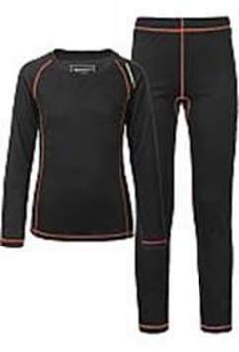

**Esme (100% merinoull)**

Färger: cerise, antracithe

Storlekar: 122/128, 134/140, 146/152, 158/164

Butikspris: 800kr

Ert pris: 400kr

