Notice of Race
Event: Swedish Championship for KONA ONE Date: 19-20 Sep 2026
Organizer: DSK by Swedish Kona One Association

Rules

  - The regatta will be governed by the rules as defined in the Racing Rules of Sailing (RRS) and with appendix S, and appendix B
The sailing instructions will consist of the instructions in RRS Appendix S, Standard Sailing Instructions, and supplementary sailing instructions that will be on the official notice board located at the race office

  - RRS 42 will apply but is changed to:
a board shall be propelled only by the action of the wind on the sail, by the action of the water on the hull and by the unassisted actions of the competitor. However, significant progress shall not be made by paddling, swimming or walking.

  - Class rules for Kona One will apply.

  - Boats and/or crew may be required to display advertising chosen and supplied by the organizing authority. If this rule is broken, World Sailing Regulation 20.9.2 applies. [DP]

  - Competitors shall when afloat wear personal flotation devices. This rule does not apply to short-term replacement or adjustment of clothing or personal equipment, or when competitors are in the harbor or under deck. Wet suits and dry suits are not personal flotation devices. This changes RRS 40. A boat that breaks this rule may be warned or penalized at the discretion of the protest committee (DP).
The personal buoyancy shall conform to the minimum standard of ISO 12402- 05 (Level 50N).

  - The competitor that is in charge on board shall follow Swedish Sailing Federations racing license regulation for competitors. This regulation applies from the year the competitor reaches the age of 12. Competitors from other countries than Sweden are exempt from this regulation.

  - If there is a conflict between languages, the English text will take precedence.

Eligibility requirements

  - To be entitled to participate in Riksidrottsförbundets championships, each competitor must comply with World Sailing Regulation 19.
In order to be awarded the title Swedish Champion (SM) the competitors shall be Swedish citizens or have resided in Sweden for at least six months the last twelve months before the regatta starts.

  - The Swedish Championship for Kona One is open for all boards in the Kona One class – recognize 2.1.

  - The competitor that is in charge on board the boat shall be a member of his/her Member National Authority or one of its affiliated organisations.
No crew is permitted to race at a National or International Regatta unless he/she is a member of his/her National Class Association (NCA). If there is no NCA, then the crew must be a member of the Kona One Association

  - Each participating boat shall be insured with valid third party liability insurance.

  - Competitors participate in the regatta entirely at their own risk. See RRS 4, Decision to Race. The organising authority will not accept any liability for material damage or personal injury or death sustained in conjunction with or prior to, during, or after the regatta.

  - When the water temperature is below +14°C clothing given a good protection against cooling in water shall be worn – wet suit, dry suit or similar.

  - Sail sizes, gender and weight groups according with the KONA ONE class rules applies

Entries

  - Entry shall be made not later than September 17nd 20:00
  - Use the entry form at site konaone.se

  - The entry fee is 750 SEK and shall be paid via
Payment to swish (1230004879) or in place!

  - Late entry fee e.g. after September the 18th is 850 SEK and will be paid either to via Swish, or cash at registration.



Registration and measurement checks
  - Registrations shall be made at the race office not later than 09.00 Hour on the 31st Aug

  - ERS A.2 - certificate shall not apply

  - ERS B.1 – position of equipment shall not apply

  - Competitor that is in charge onboard, according to §1.6 shall be able to present a valid license for competitor.

  - A boat or equipment may be inspected at any time for compliance with the class rules and sailing instructions. On the water, the race- or/and the technical committee can instruct a boat to proceed immediately to a prescribed location for inspection.

  - Substitution of damaged or lost equipment will not be allowed unless approved by the race committee. Requests for substitution shall be made to the Race committee at the first reasonable opportunity.

  - Competitors will be weighted according to Class Rule C.2.3, see below

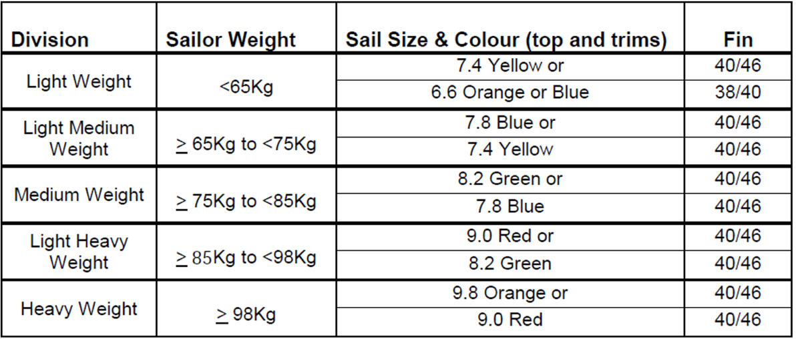

  - Only one sail as per Class Rule C.2.3 may be used in an event, except when the sail has been lost or unintentionally damaged beyond repair. A replacement may be made only with a sail of the same size and with the approval of the Race Committee.

  - A competitor may not be substituted without the written permission of the race committee.

  - An inspection plan is held by the race committee, not official

  - Supplementary Sailings Instructions will be handed out at registration

Time schedule
5.1

Saturday 19st September
 | 4-5 races are scheduled
09.00-10.00 | Registration, possibly equipment inspection, personal weighing of  competitors
10.15 | Skippers briefing
11.00 | First warning signal 2-3 races
13:00 | Lunch
14:30 | Sailing (2-3 races)
16:30 | Last start
18:30-19:00 | Dinner At Restaurant Sjövik
Sunday 20 September | 4 races are scheduled
09.30 | Skippers meeting
10:15 | Sailing (2 races)
12:30 | Lunch
13:30 | Sailing (2 races)
No warning start after 15:30 | Last start
ASAP after the regatta is completed. | Prize giving ceremony at race  office

Race format
  - The regatta will be implemented as fleet racing in a straight series.

  - 8-9 races are scheduled

Racing area

  - The racing areas will be Outside bay Varamon, Motala See attachment.

Implementation

The course
  - Kona Up/ down wind.
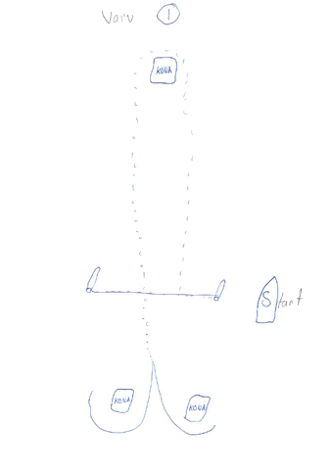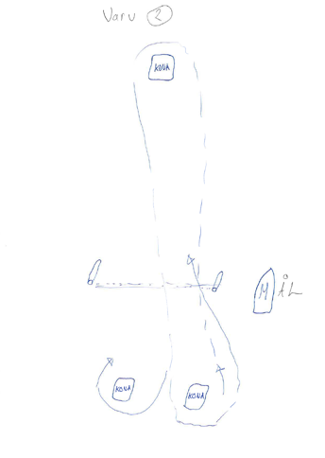

Protests and penalty systems
  - As provided under the Racing Rules of Sailing, the no-pumping rule shall be enforced either by a protest filed by the race committee against a sailor in violation of Rule 42, or by sound signals and/or flags as follows. A competitor performing repeated rig movements shall be warned by the on-water umpires by means of a sound signal and/or a yellow flag and penalized with a 720 turn with immediate effect. Will be handle direct at the course, no possible protest on the jury at the water. There will not be no any handle of this rules after the race.

Scoring

  - The low point scoring system of RRS Appendix A will apply, modified so that when four or fewer races have been completed; a boat’s series score will be the total of her race scores.

  - 3 races are required to be completed to constitute a championship.

Prizes

  - Eventually prizes from the Class Association

  - Possible sponsor prizes

Rules for support persons

  - Support persons shall follow Swedish Sailing Federation safety code.

  - Support person shall launch, berth and take up his craft (coach boat) as directed by the organizer.

  - Support person shall follow RRS 1, 2 and 55 and not subject a competitor to risk breaking RRS 41.

  - During the race, a support person shall not be closer to a competitor than 50 meters, except when the support person acting under RRS 1.1.

Date: 2026-03-23

Ver.: 1.0

Name: Joachim Larsson

