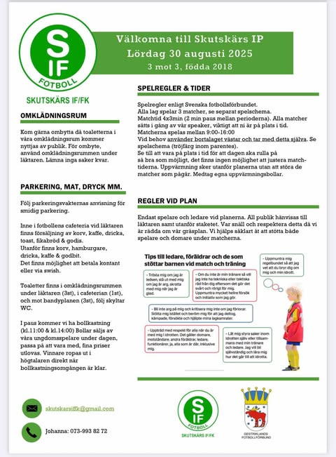

Lagindelning

*Orange*

**Adam**

Edward

Malte E

Svante

Adrian

Frank

*Svart*

**David**

Ebbe

Moin

Rio

Levi

Alfred

Sixten

*Blå*

**Thomas**

Lias

Ture

Oscar

Alve

Simon

*Grön*

**Aleks**

Frans

Benji

Oliwer

Tage

Alfons

*Vit*

**Klrille** (Vides pappa)

Vide

Max

Leon

Ludvig

Albin

