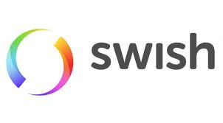

123 000 4192
Vi tar ej Swish under 10kr

123 000 4192
Vi tar ej Swish under 10kr


