**Spelschema Coop Cupen Sunnanå Lag Blå**

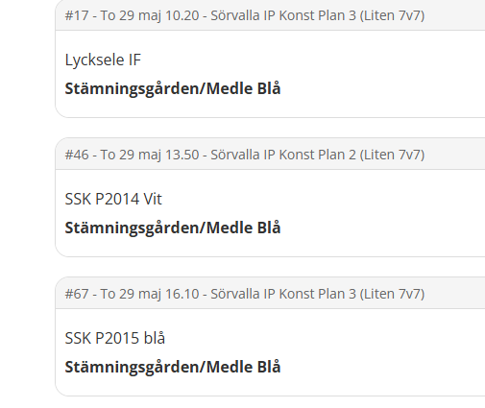

| ***Lag blå*** |
| --- |
| Elias Vikström |
| Melker Engman |
| Mikko Malm |
| Oliver Dahlström |
| Loui Lundgren (L) |
| Wille Berglund (L) |
| Otto Sundbom |
| Melker Lindberg |
| Adam Lindahl |
| Lennox Myrgren |
| Seth Vanes |
| Tristan Andersson |
| Valter Axelsson |
| Isak Aronsson |

**Coop Cupen Sunnanå Lag Vit**

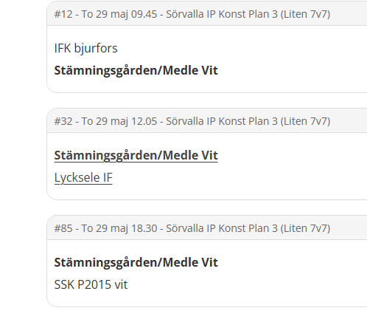

| ***Lag vit*** |
| --- |
| Liam Karbin (L) |
| Milo Hansson |
| Andrew Tuolja |
| Anthony Tuolja |
| Alfons Gullstrand (L) |
| Olle Emthén (L) |
| Alfred Emthén (L) |
| Frans Marklund |
| Adriel Maschio Padilla |
| Charlie Fürstenhoff (L) |
| Gustav Söderlund |
| Aron Åström |
| Lo Ejrendahl |
| Nebi Gehbrihiwet |
| Marko Kochkovski |