KINNA IF RÖD
- Albert L
- Kasper
- Wilgot
- Isak
- Albert A
- Filip A
- Hjalle
- Leon
- Emin
- Linor
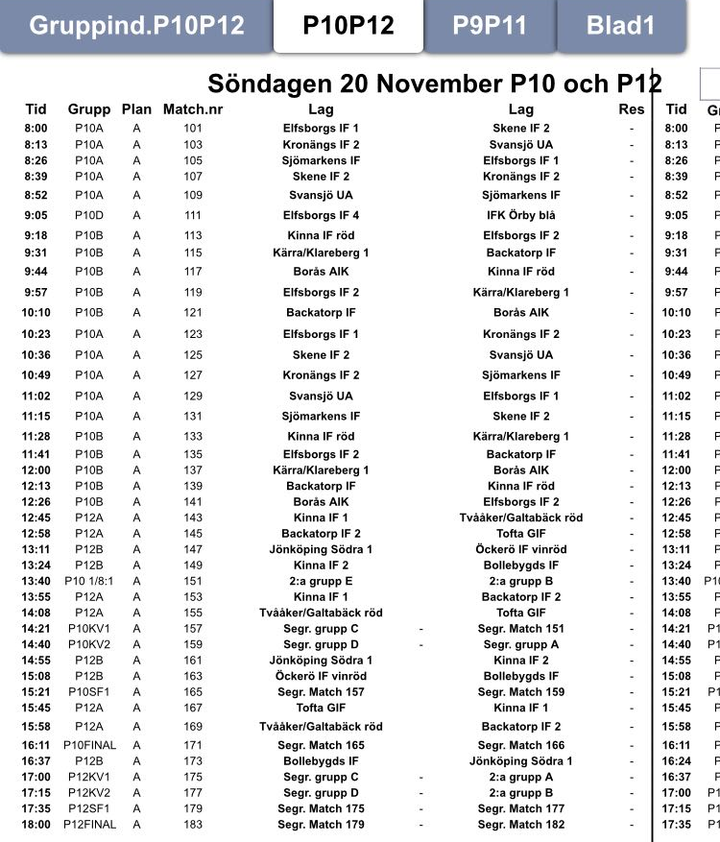

KINNA IF BLÅ
- Elion
- Gabriel
- Noah
- Philip J
- Hugo
- William
- David
- Benjamin
- Richard

