Fikalotteri för IBFF F-10
Lottpris 20kr/st
- _____________________________________________________
- _____________________________________________________
- _____________________________________________________
- _____________________________________________________
- _____________________________________________________
- _____________________________________________________
- _____________________________________________________
- _____________________________________________________
- _____________________________________________________
- _____________________________________________________
- _____________________________________________________
- _____________________________________________________
- _____________________________________________________
- _____________________________________________________
- _____________________________________________________
- _____________________________________________________
- _____________________________________________________
- _____________________________________________________
- _____________________________________________________
- _____________________________________________________

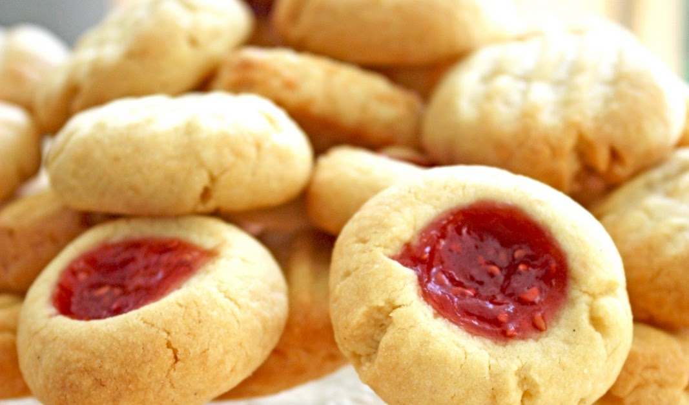
Dragning av två vinstnummer sker den 7/6 2021. Vi skriver ut de två vinnande numren på laget sidan. Fikat lämnas till vinnarna senast 14/6.
Tack för ditt stöd! // IBFF F-10

