Tack för att du stödjer

Oss i Borlänge InnebandyKlubb

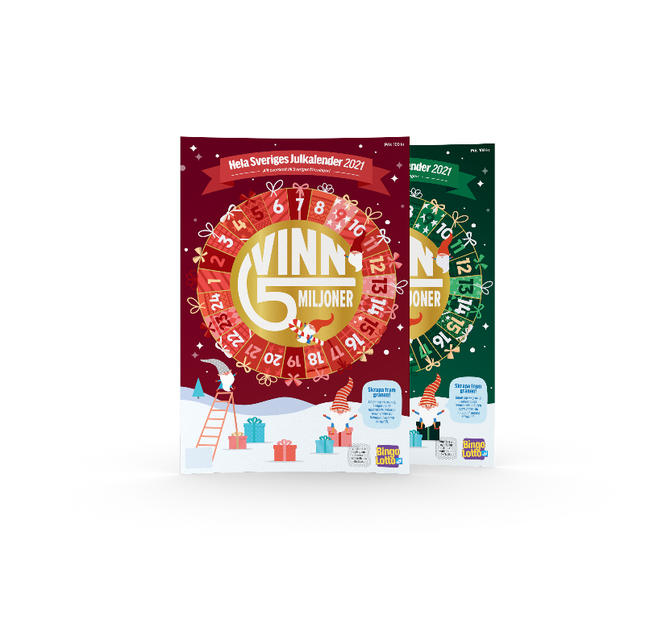**och köper Bingolottos Julkalender**

Säljare_________________________________

Förening:______________

|  |  |  |  |  |  |  |
| --- | --- | --- | --- | --- | --- | --- |
|  | Julkalendern | |  |  |  |  |
| Namn & telefon | 100 kr | Betalat |
|  |  |  |
|  |  |  |
|  |  |  |
|  |  |  |
|  |  |  |
|  |  |  |
|  |  |  |
|  |  |  |
|  |  |  |
|  |  |  |
|  |  |  |
|  |  |  |
|  |  |  |
|  |  |  |
|  |  |  |
|  |  |  |
|  |  |  |
|  |  |  |
|  |  |  |
|  |  |  |

Totalt antal: ___________ ____________