Tack för att du stödjer

Oss i Borlänge InnebandyKlubb

**och köper Bingolottos Julkalender & Bingolotter till Uppesittaren 23/12**

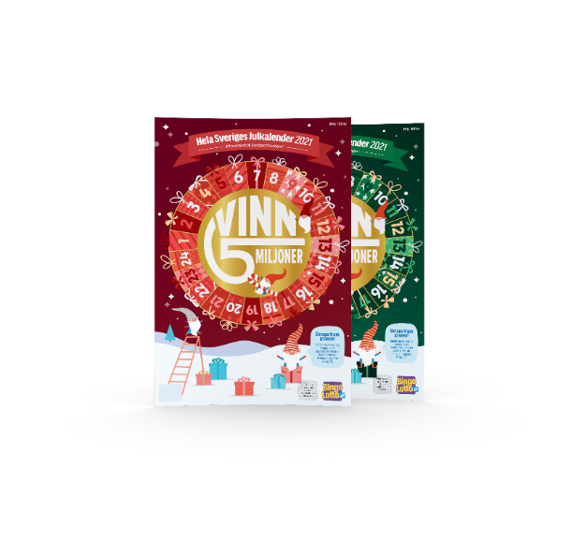Säljare_________________________________

Förening:_______________________

|  |  |  |  |  |  |  |  |  |  |  |  |  |  |  |  |  |
| --- | --- | --- | --- | --- | --- | --- | --- | --- | --- | --- | --- | --- | --- | --- | --- | --- |
|  | Uppesittaren Julkalendern | |  |  | |  |  | |  |  |  |  |  |  |  |  |
| Namn & telefon | 100 kr | 100 kr |  | | Betalat | | |
|  |  |  |  | |  | | |
|  |  |  |  | |  | | |
|  |  |  |  | |  | | |
|  |  |  |  | |  | | |
|  |  |  |  | |  | | |
|  |  |  |  | |  | | |
|  |  |  |  | |  | | |
|  |  |  |  | |  | | |
|  |  |  |  | |  | | |
|  |  |  |  | |  | | |
|  |  |  |  | |  | | |
|  |  |  |  | |  | | |
|  |  |  |  | |  | | |
|  |  |  |  | |  | | |
|  |  |  |  | |  | | |
|  |  |  |  | |  | | |
|  |  |  |  | |  | | |
|  |  |  |  | |  | | |
|  |  |  |  | |  | | |
|  |  |  |  | |  | | |

Totalt antal: __________ ________________