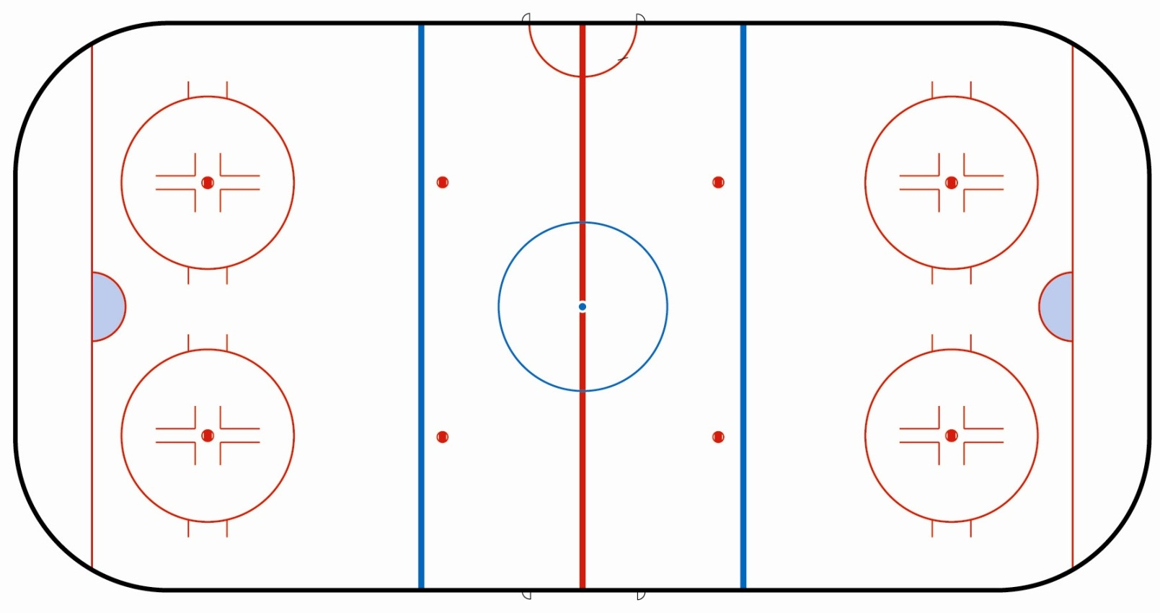
Övning:___________________________________________________________________________________________________________________

