MATCH: __________________________________
DATUM: ___________________________
DOMARE:
__________________________________
AD 1:
__________________________________
AD 2:
__________________________________
ANTECKNINGAR
HD______________________________________________________________________________________________________________________________________________________________________________________________________________________________________________________________________________________________________________________________________________________________________________________________________________________________________________________________________________________________________________________________________________________________________________________________________________________________________________________________________________________________________________________________________________________________________________________________________________________________________________________________________________________________________________________________________________________________________________________________________________________________________________________________________________________________________________________
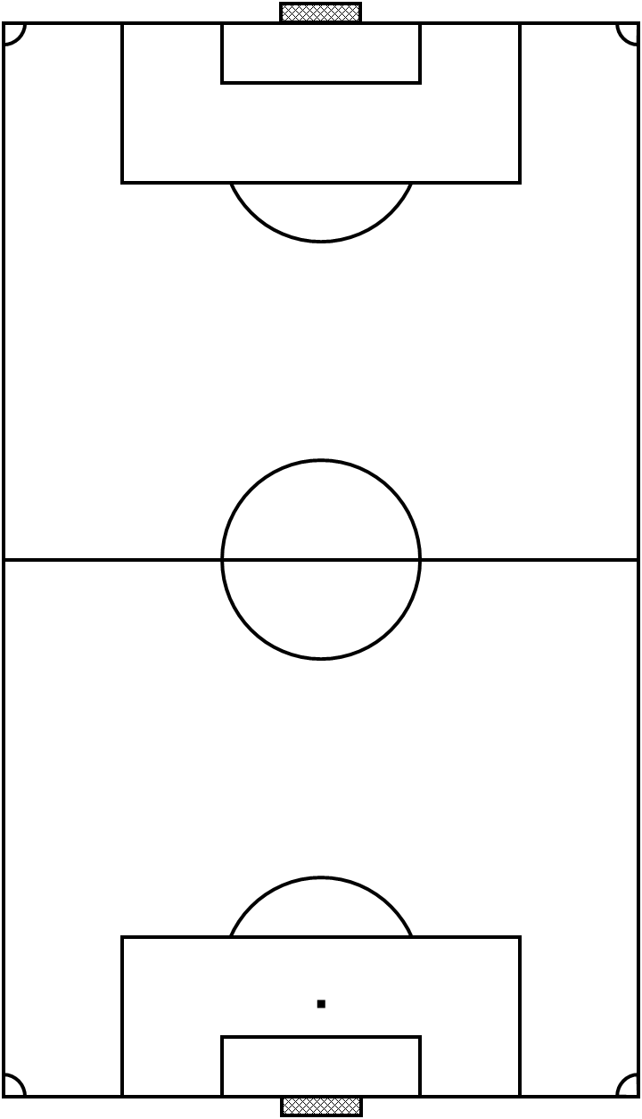
________________________________________________________________________________________________________________________________________________________________________________________________________
ANTECKNINGAR
AD1_____________________________________________________________________________________________________________________________________________________________________________________________________________________________________________________________________________________________________________________________________________________________________________________________________________________________________________________________________________________________________________________________________________________________________________________________________________________________________________________________________________________________________________________________________________________________________________________
AD2_____________________________________________________________________________________________________________________________________________________________________________________________________________________________________________________________________________________________________________________________________________________________________________________________________________________________________________________________________________________________________________________________________________________________________________________________________________________________________________________________________________________________________________________________________________________________________________________________________________________________

