

**TACK FÖR DITT STÖD!**

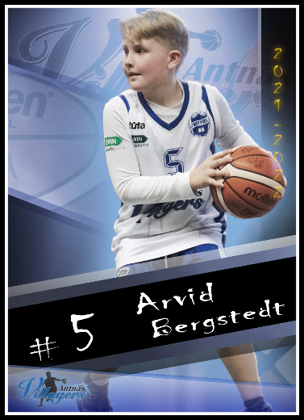

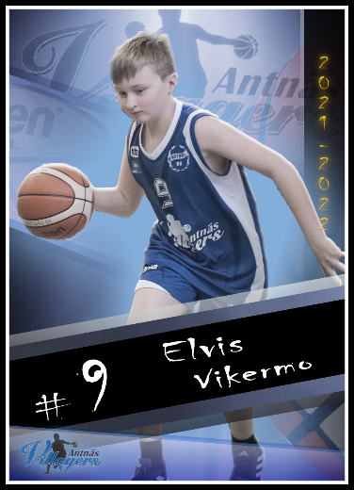

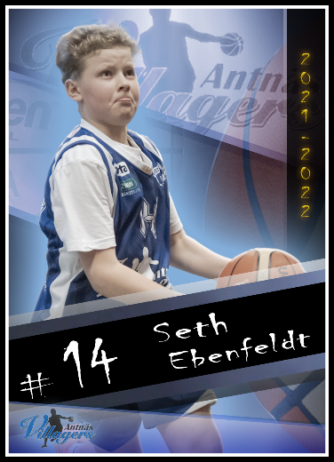

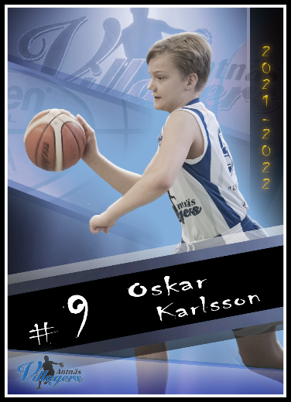

**ANTNÄS BK P1011**