1: Lila Dress

2:

3:

4:

5: Viktor Eriksson

6:

7: Joel Blychert [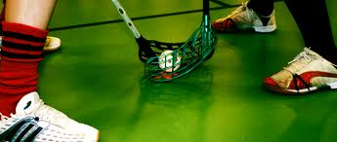](http://www.google.se/imgres?imgurl=http://www.mikroif.com/bilder/tekning.jpg&imgrefurl=http://www.mikroif.com/&h=315&w=741&sz=282&tbnid=PEDzhL2JMy1AYM:&tbnh=54&tbnw=127&prev=/search?q=Bilder+innebandy&tbm=isch&tbo=u&zoom=1&q=Bilder+innebandy&docid=BId2g0BFvGaPJM&sa=X&ei=PBWLTrCILc3E4gSJgMn3Aw&ved=0CDYQ9QEwAw&dur=10387)

8: Mattias Kling

9: Rasmus Nero

10: Bachir Mukhtar

11: Gustav Hvirf

12: Oliver Alving

13: Sebastian Sigfridsson

14: Martin Lundberg

15:

16:

17: Willem Bergström

18: Jakob Bråtenholme

19: Edvin Lundmark

20: Patric Ahlmen

21: Magnus Engqvist

24: Martin Karlsson

46: Tom Berglund

77: Alexander Gustafsson

96: Simon Svensson