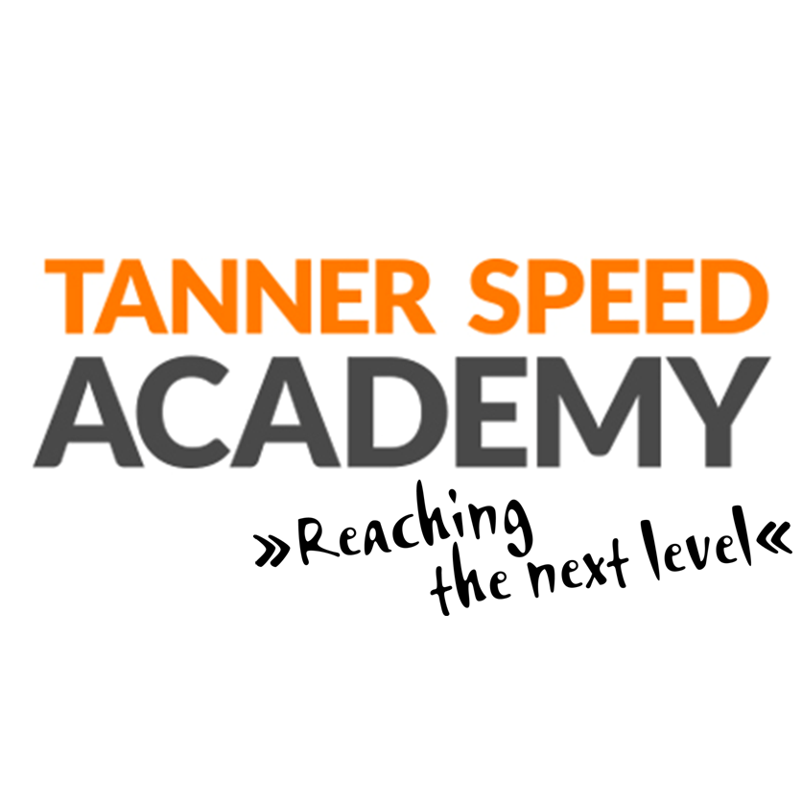
www.tannerspeedacademy.com
Instagram: tannerspeed
Contact: carsten@tannerspeedacademy.com
Phone: 0706-202528

Coaching points for Golden 8
  - Upright body position, i.e. full hip extension
  - Not touching the ground with the heel. Active footwork.
  - Actively swinging arms to support the legs
The Tanner Speed Golden 8 drills are methodical exercises that imitate running movements. By mastering these exercises, proper running motions become automatic which then improves your running technique.
Basic running drills benefits:
🔸 Warm-up: warming up is a process that gradually raises the body temperature so that the athlete is physically and mentally prepared for the training or game.
🔸 Better technique: running drills teach you proper posture and foot placement during a run. By improving the running technique, it will also improve the running economy. In other words, you will run faster while spending less energy. That means you can run longer with high speed.
🔸 Mind-muscle connection: running drills improve communication between nerves and muscles by quickening nerve impulses that send signals to muscle fibers. We call it neural pathways. As a result, the muscles will have a better coordination in more intensive trainings or races.
Do the drills at least 2-3 times per week. But if you can do it more often the results will even be better.

