About the authors
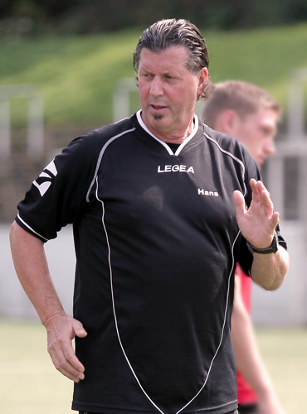

Hans Tanner
In his 15 years as FC Zurich academy’s coordination and running coach from 1994 to 2008, Hans Tanner developed the Tanner Speed concept. And it seems to have worked.: Five players on the Swiss team tht took the U17 world championship in 2009 were Tanner Speed alumni.
Before he was the responsible head coach for the Swiss national high jumping team at the Olympics 1980/1984. Hans best work was with high jumper Roland Dahlhäuser who he coached to jump 2.31 m and finish 5th place at the Olympics in 1980.

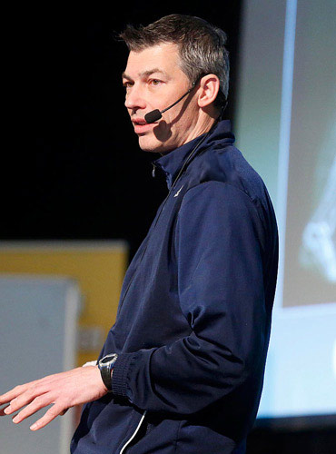

Carsten Effertz
Regarded as one of the best Speed Coaches in team sports in Europe, Carsten holds a degree in training science and joined several courses of different areas of strength and conditioning to be always up to date on a scientific level.
Presenter at coach congress and coach licenses courses on international level for several Football and Coach associations in Europe and Asia.
Currently he is responsible for the physical development of football players in the age groups U12-U19 at IFK Göteborg Academy.

Elevate your speed

Today's football is becoming more and more athletic. The challenges for the players are getting bigger. In particular, the running and coordinative skills are becoming increasingly important.

The speed of the player plays an pivotal role: being the first on the ball, attacking the opponent if possible before he turns, creating an outnumber, pressing, starting explosive and well timed in the interfaces and free spaces, quick decelerations and fast changes of direction.

Speed ​​can only be improved with the right technique and athletic training.
Sprints with a ball are always suboptimal and do not reach the intensities to train the fast twitch muscle fibers.

And speed without the ball is a crucial component. 98% of the playing time the players are moving without ball. Players with better running and coordination skills have a much better chances of being successful.

But running is rarely specifically learned in football. It is a complex, sporting activity. With a correct posture and good running coordination, the requirement to be faster with the ball can be fulfilled more easily.

Athletic speed training is based on good mobility, stability, coordination, strength, speed and power.

Tanner Speed Academy supports players, speed trainers, clubs and associations with training, demo training, performance analyzes and special material for optimal coordination training.
More information at www.tannerspeedacademy.com

Speed training – Essential for a players career
Explosive takeoff speed, power and the ability to jump are critical factors in today's football.

Unfortunately, coaches, who do not consider the complexity of rapid movement simply make their players work out their leg muscles, then wonder why they’re not getting faster. The reason is that efficient speed requires optimal coordination of all muscles involved. The central nervous system is aware of movements rather than the muscles.

Good running coordination is therefore an essential prerequisite for becoming a successful football player. Sporting gestures are usually extremely complex actions. Footballers perform quick movements, many tempi- and change of directions and at the same time concentration on the ball, the opponent, the own and opposing team behavior. So many things happen at the same time in a short time and in limited spaces that need to be coordinated with one another. In order to achieve the best possible coordination, the training methods must be adapted accordingly.

Tanner Speed method

Introduction

Especially young players can benefit from the training method because it optimally complements the usual football training. The running coordination is built into this concept as a supplement to basic or team training in order to consolidate and refine the technical processes.

Running training is based in particular on the following aspects:

1. Erect posture
2. Running on balls of feet
3. High stride frequency
4. Qualitative training (i.e. fresh and unfatigued)

Running technique: Negative factors

There are four main causes that negatively affect the running behavior of soccer players:

1. Muscular imbalance in the pelvic area
2. Insufficient foot tension due to weak lower leg muscles
3. Poor inter-muscular coordination
4. Lack of ability to achieve a high cadence

Muscular imbalance in the pelvic area

Due to hours of sitting and a low level of everyday activity we have weak abdominal and back muscles. This lack of exercise can cause the lumbar spine and hamstring muscles to shorten. As a result of these shortenings in the hip, the players mostly tend to land on the heel, which causes a "sitting" running position. Overworking the muscles in the front of the thigh and underworking the muscles in the back. In order to prevent this, the Tanner Speed ​​training concept strongly emphasizes maintaining an upright posture.

Weak foot muscles

Without foot muscle tone it is impossible to achieve a good acceleration. Video analysis has shown that most footballers do not really engage their ankles while running. But a high foot tension results in shorter contact times and the possibility of faster changes of direction. Running on your heels shifts the body's center of gravity backwards (behind the foot) which effectively puts on the brakes. But when you lead with the balls of your foot, on the other hand, your weight automatically shifts forward, moving your whole body forward faster in the running direction.

TIP: Make barefoot running exercises part of the training program. Running without the support of a shoe strengthens your feet muscles and improves your feel for the right way to run.

Insuffient intermuscular coordination and stride frequency

Many players have trouble accelerating explosively from a standing position, usually because their strides are too long and their stride frequency is too low. But short strides are best for the first 5-10 meter, especially in soccer: Shorter strides make for faster accelerating. And of course, to achieve a high stride frequency, all the muscles involved have to work together in the best possible way.

Why train running coordination?

The speed of muscular exertion is limited by neuromuscular coordination. That means that the body will move most effectively and efficiently within a range of speed that the nervous system or the motor unit has been programmed to allow!
The purpose of coordination training is to teach the brain to activate the muscles the right way in the right moment. The muscles need to learn to work together in the best possible way.

The best strength training program in the world for the leg muscles is worthless if the muscles are not properly activated and coordinated in the context of an actual movement. So the first step of coordination training is brain training. And the earlier in their career players start, the more their playing careers will benefit. Besides running coordination, they will also be improving their reaction speed and takeoff power.

And there is another positive side effect: Coordination training is an excellent way of preventing injuries.

In situations demanding good running coordination and football specific skills, players who have received extensive coordination training will have a leg up on players who haven’t: Instead of having to mentally “recalibrate” for each movement sequence, they will be able to react instantaneously and execute the necessary movements automatically, just as they have been trained to do. This saves mental energy, which in turns saves valuable parts of a second.

On the following pages we present some of the many training activities in our program: The “Golden 8 warm-up” exercises. Good technical execution is essential for all these exercises. Fast running depends on good posture and foot positioning, plus active use of the arms.

Exercises - Golden 8 warm-up program

Warm-up

Running coordination begins with warm-up. These exercies, which we call the „Golden 8“, not only improve running coordination, they also help to activate all the muscle groups we use in football. The entire sequence takes about 10 minutes and can easily be incorporated into your standard warm-up program.

Set-up for Golden 8

To start, divide players into two groups. For each group, set out two cones spaced 20-25 meter apart. Players run to the far cone, then jog back to their starting position. Adjust the running distance so that all players are constantly in motion and no one has to wait.

TIP: For coaches: The first 4-5 meter are your „coaching zone“. Any mistakes should be corrected here so that players can spend the rest of the run working on them.

Essential coaching points

It is essential to focus on the execution of the technical sequences as it will speed up players‘ reaction time and muscle contraction rate, activating their nervous system and heigthening all of their senses.
But how is the approach to a new exercise? In the beginning a new movement will be executed with a high amount of coactivation of other muscles, due to the lack of experience. This coactivation will slow down the action. If all muscles working at the same time instead of organized in the right way the result will be suboptimal.
Repetition is the key! The coordination of the muscles involved will progress towards greater efficiency and increased speed of execution the more often it is repeated. Just take the example when you learn how to write or to dance. The more often it is done the better you will get.

Therefore, to achieve these benefits, you have also got to pay attention to the coaching points shown below and focus on a high quality of execution:
Coaching points for Golden 8
  - Upright body position, i.e. full hip extension
  - Not touching the ground with the heel. Active footwork.
  - Actively swinging arms to support the legs
It’s always easier to correct before players internalize them. Or in other words. Focus on the execution not on the result. You can control only the execution.

How to start:
- Do only the first 2-3 drills in the first session. Each drill with a high number of repetitions (8-10). In the next session only 4-6 reps and add another drill and so on.
- Until the player can do the full program. Then it will be each drill twice as a warm-up program.
- Keep focus on the position of the feet. The heels should never touch the ground. And the body position should be straight to improve the strength in the upper body.
- The Golden 8 is to improve the basic running mechanics. You should do this for at least 2-3 times per week.

Summary Golden 8

For coaches: The great advantage of these exercises is that players eventually learn to do them on their own. This frees you to seet up other activities without worrying whether your players are going to be properly prepared for the phzsical and mental demands of the training session (or match) ahead.
For players: An execution of the warm-up program with high focus also activates the nervous system through the increase in reaction and contraction speed and the sensory organs in the form of an increase in the absorption capacity of the various analyzers. The players are well prepared for the upcoming training session or match.

Tipp: The warm-up program can start already before the scheduled training time on the pitch. It requires only very little space. This leaves more time for the football training on the pitch during the scheduled time.

